Nama : Irvan Rizky Ariansyah

NPM : 202310015

Kelas` : TI 20 PA

**# Tugas Mikroservices Validation**

Programs

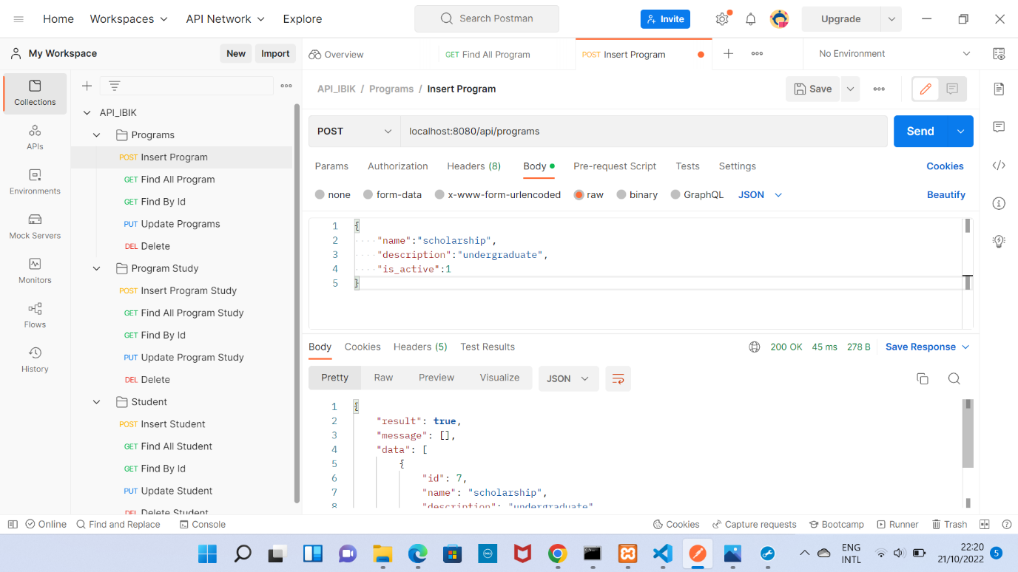

Gambar 1 Create Success

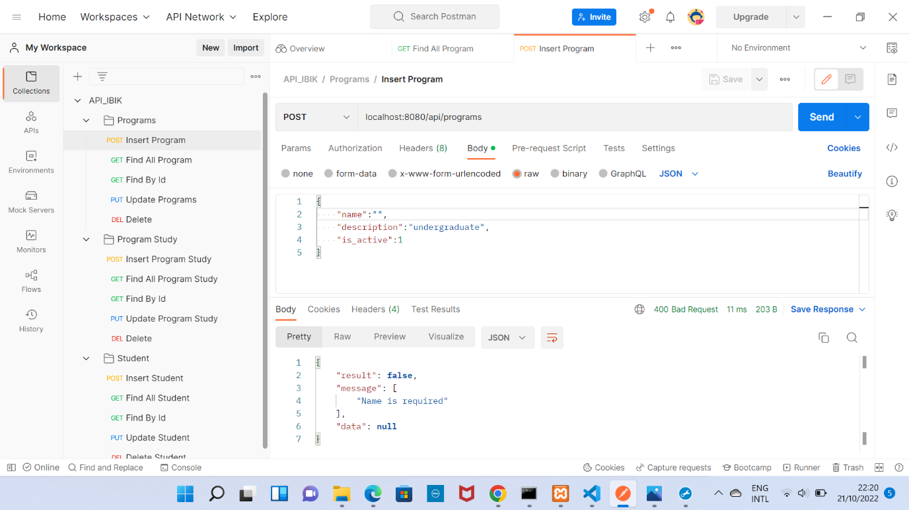

Gambar 2 Create Error

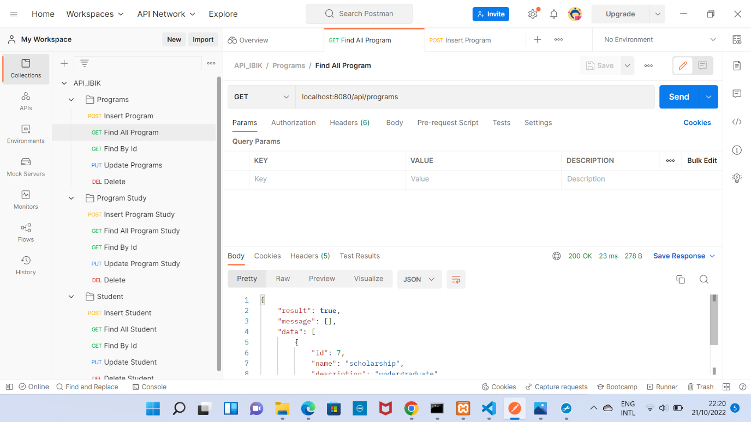

Gambar 3 Retrive Success

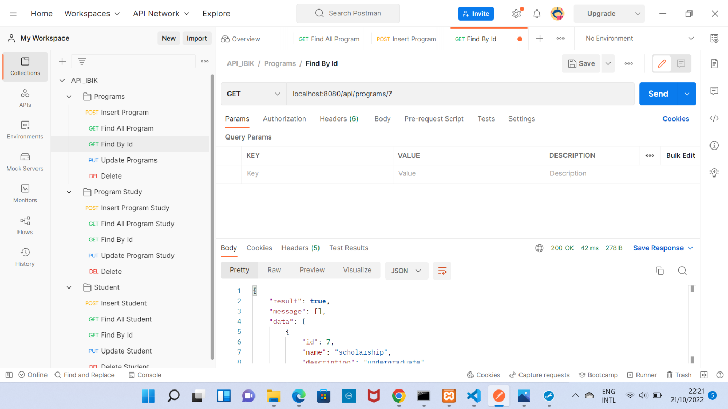

Gambar 4 Retrive Success

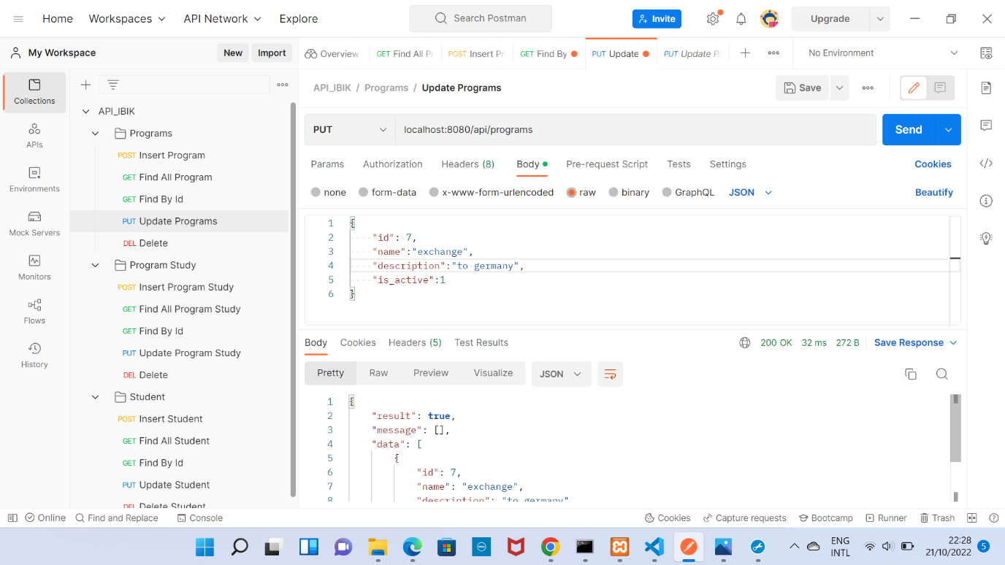

Gambar 5 Update Success

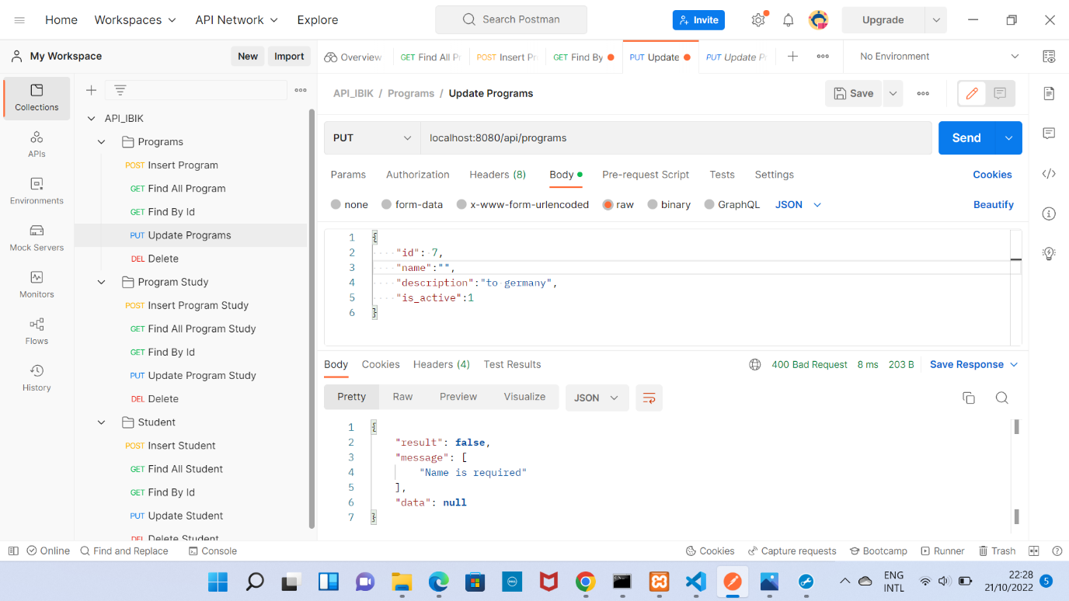

Gambar 6 Update Error

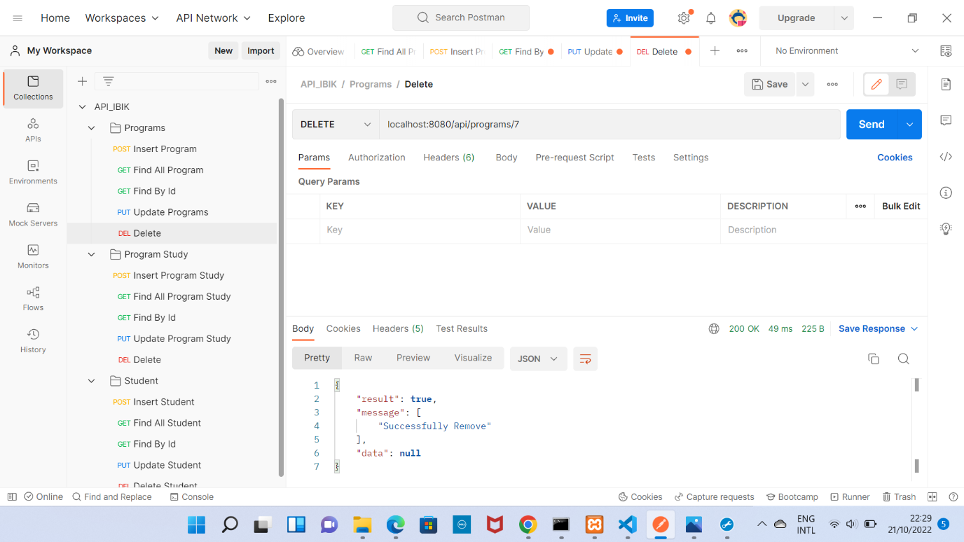

Gambar 7 Delete Success

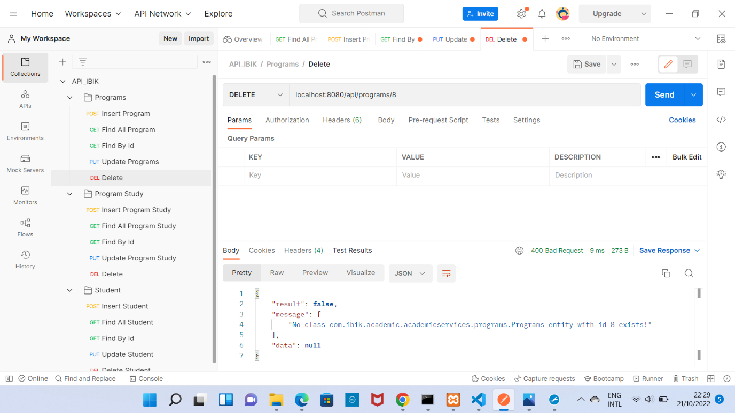

Gambar 8 Delete Error

Program Study

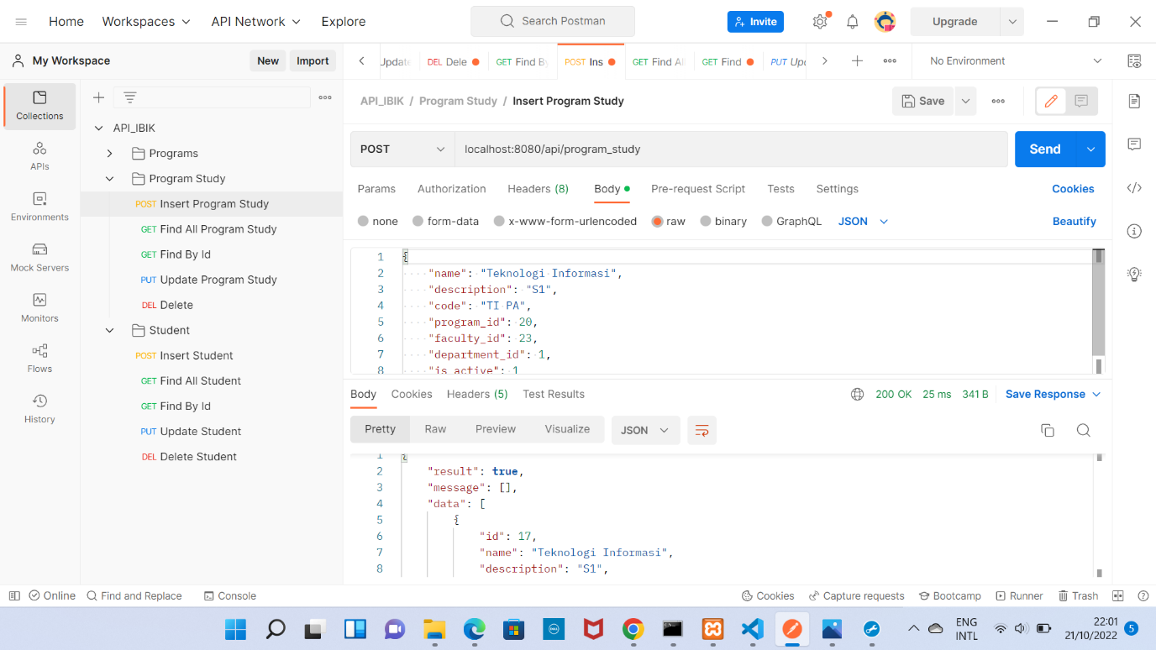

Gambar 9 Create Success

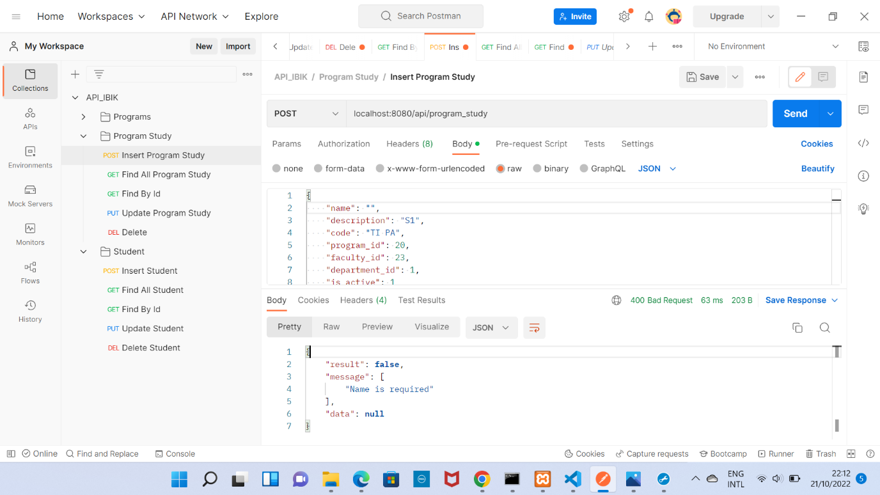

Gambar 10 Create Error

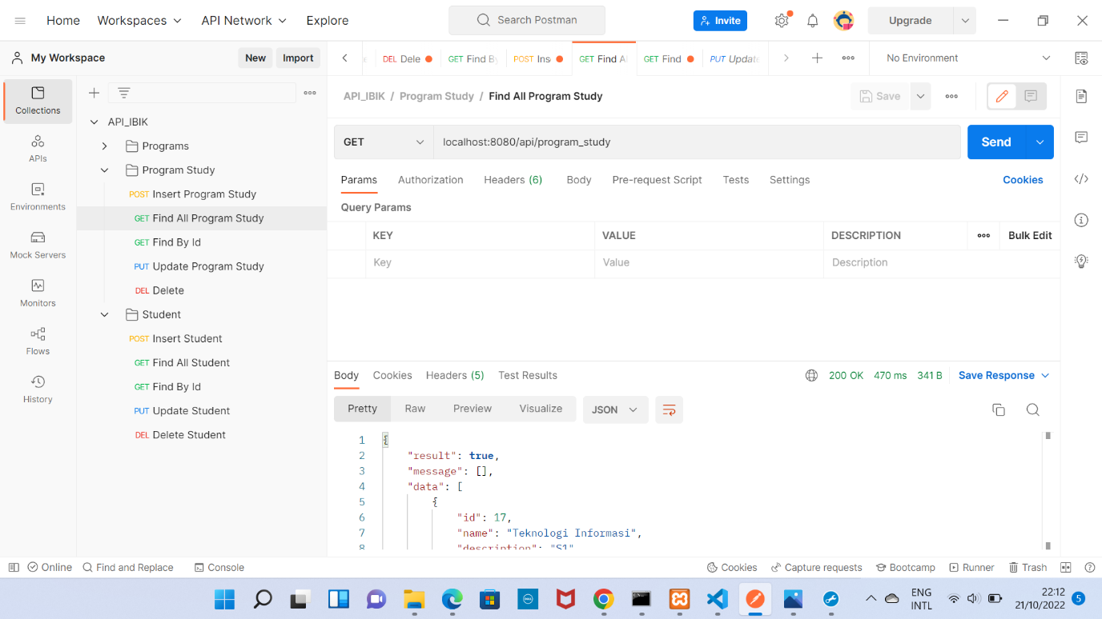

Gambar 11 Retrive Success

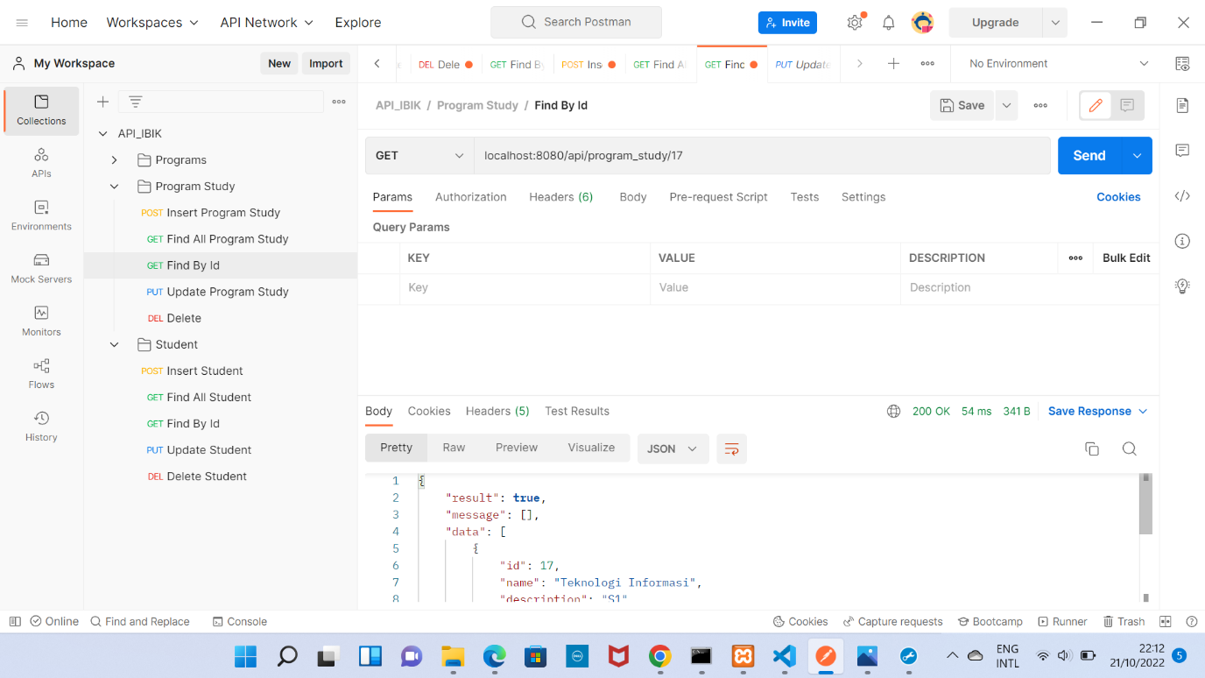

Gambar 12 Retrive Success

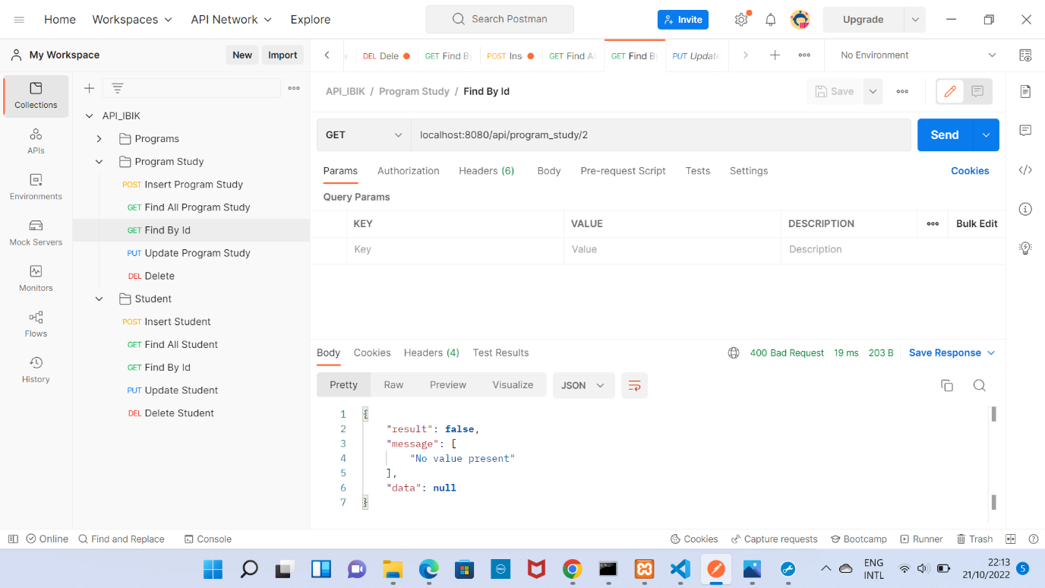

Gambar 13 Retrive Error

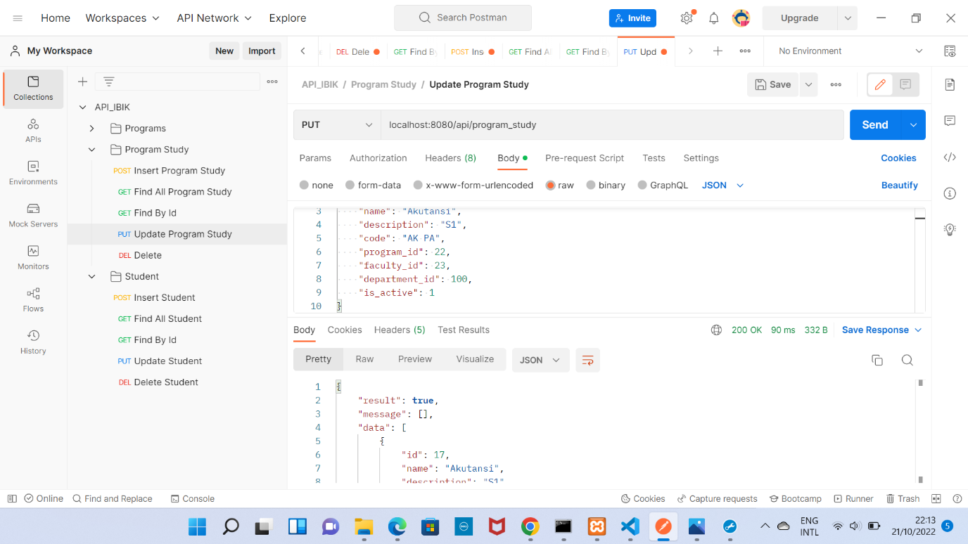

Gambar 14 Update Success

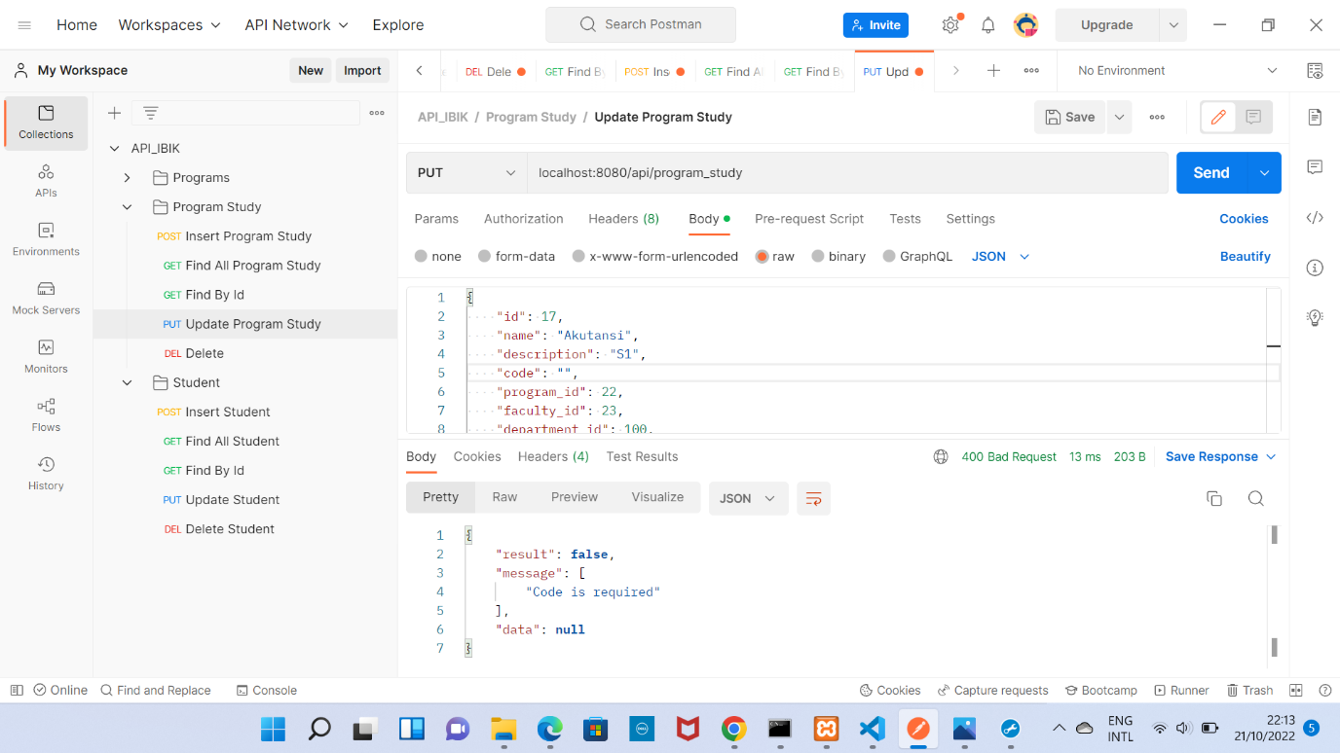

Gambar 15 Update Error

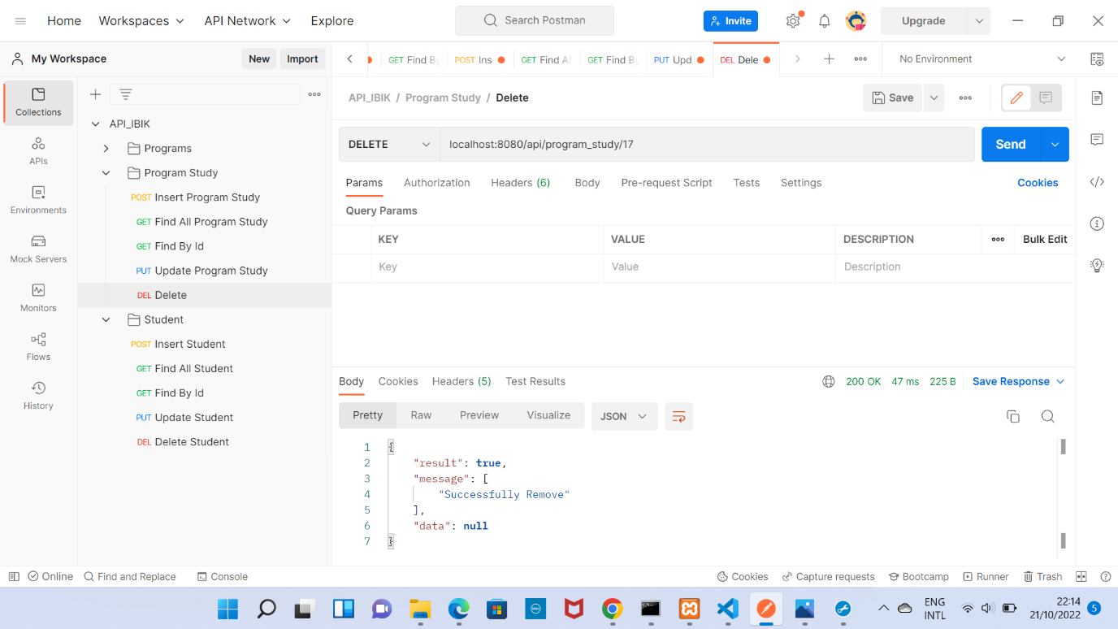

Gambar 16 Delete Success

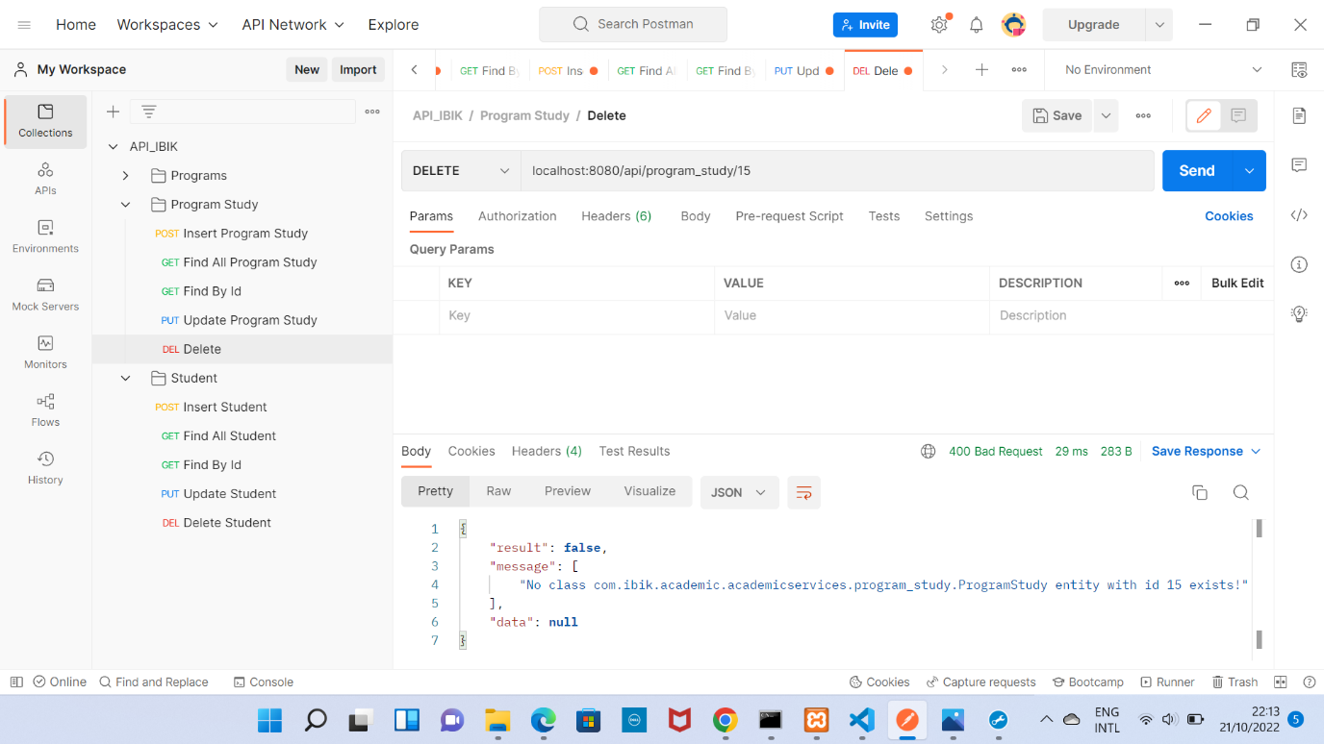

Gambar 17 Dellete Error

Student

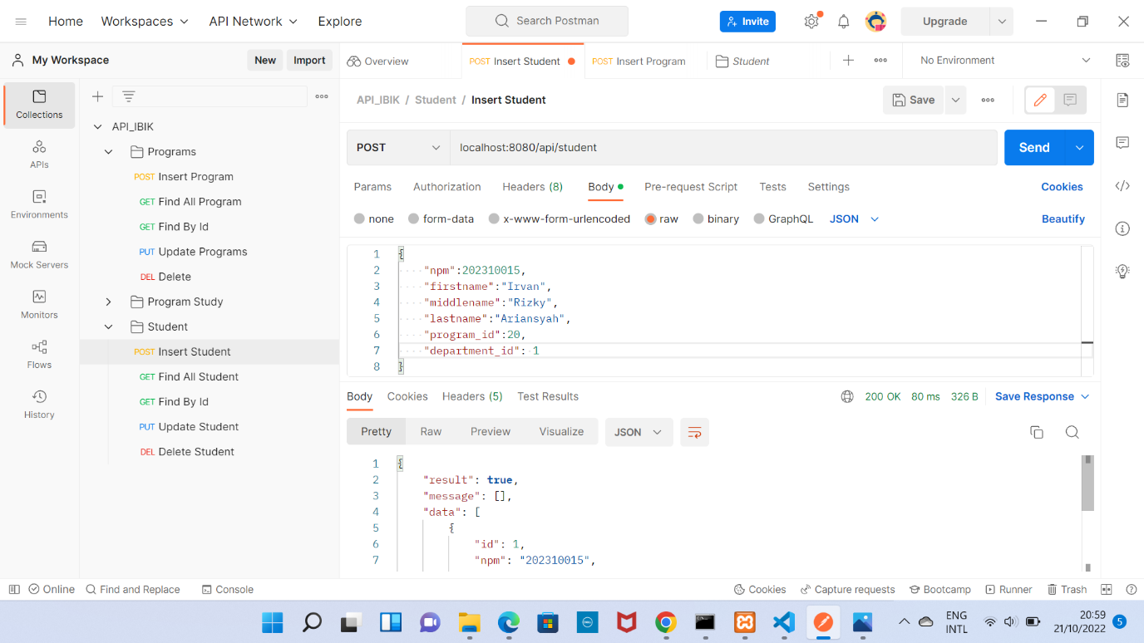

Gambar 18 Create Success

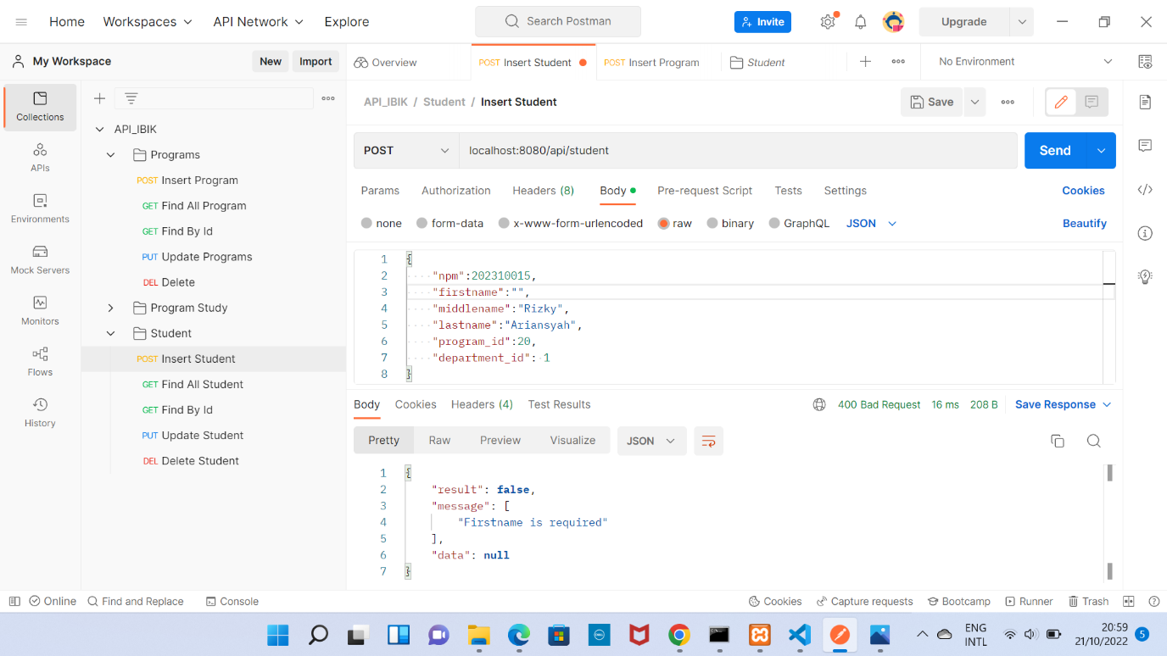

Gambar 19 Create Error

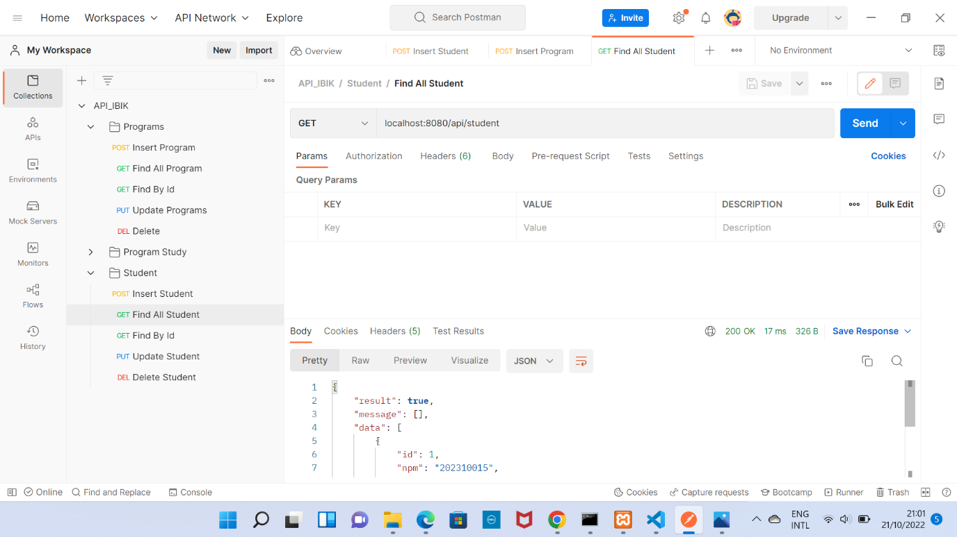

Gambar 20 Retrive Success

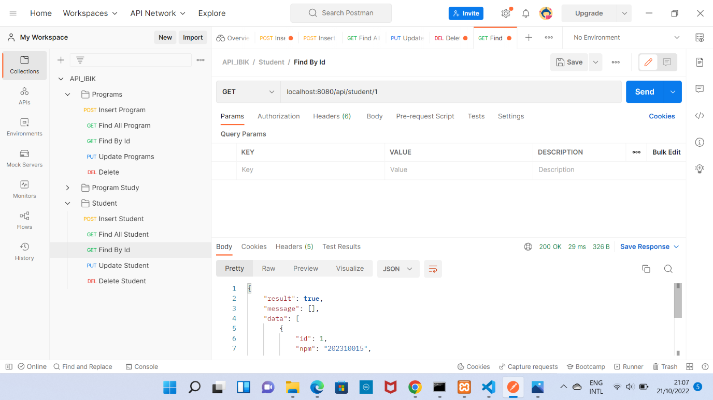

Gambar 21 Retrive Success

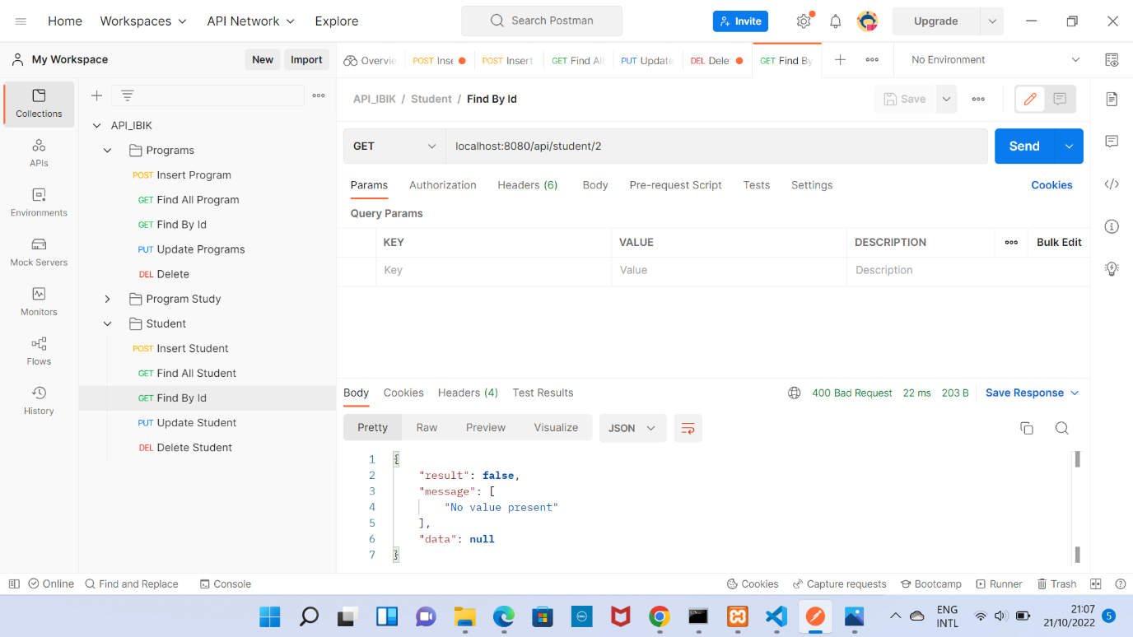

Gambar 22 Retrive Error

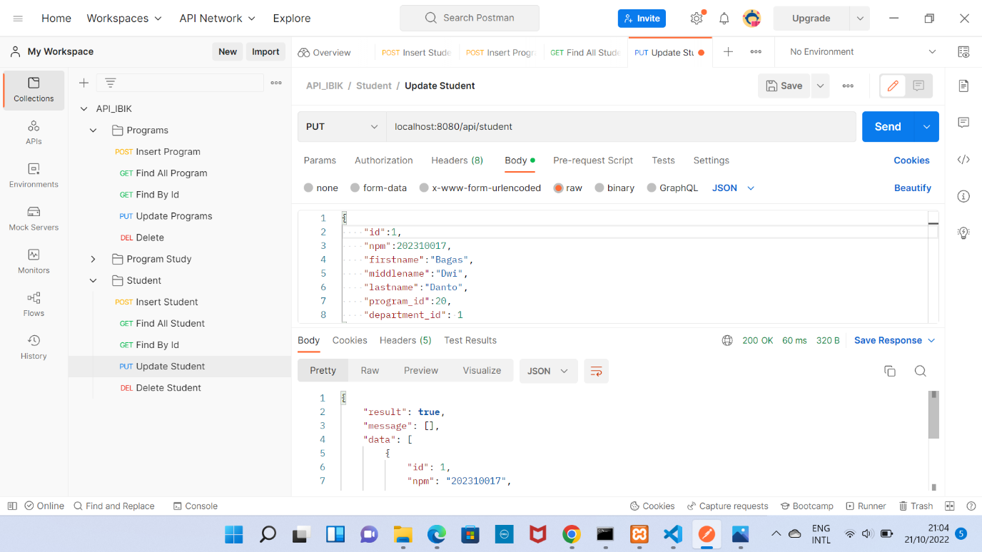

Gambar 23 Update Success

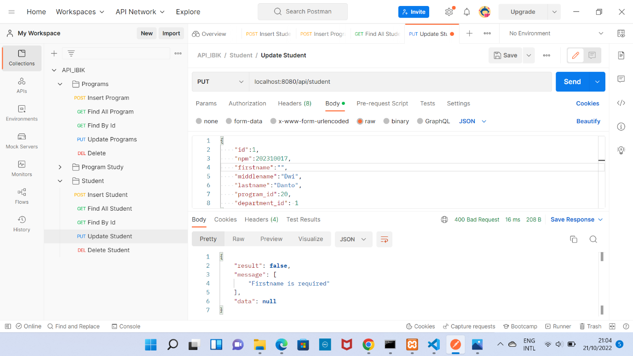

Gambar 24 Update Error

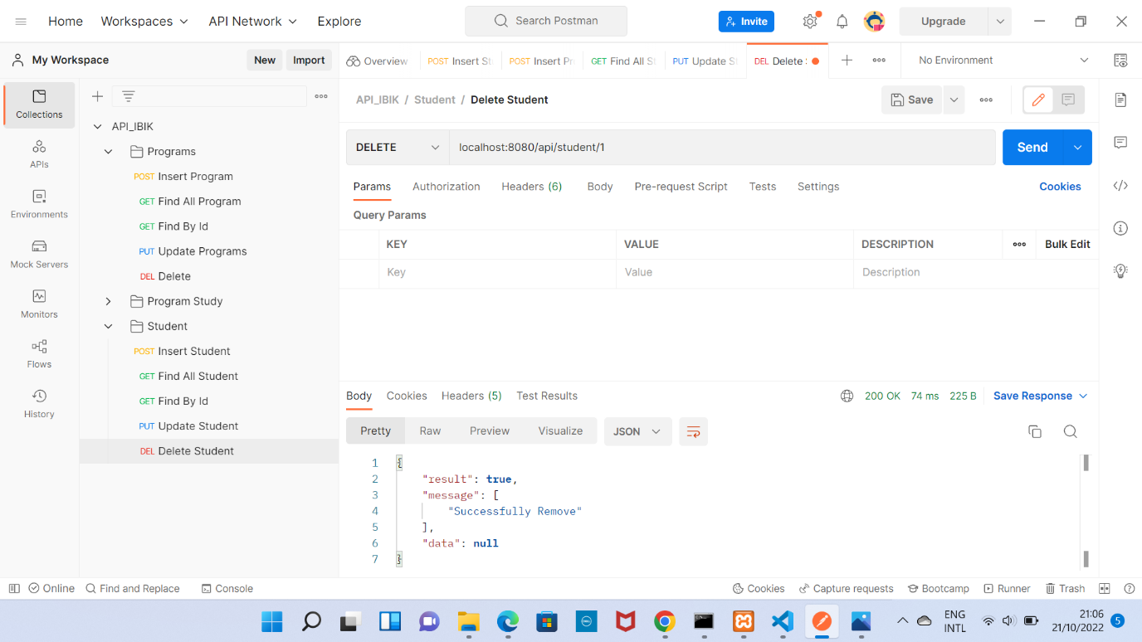

Gambar 25 Delete Success

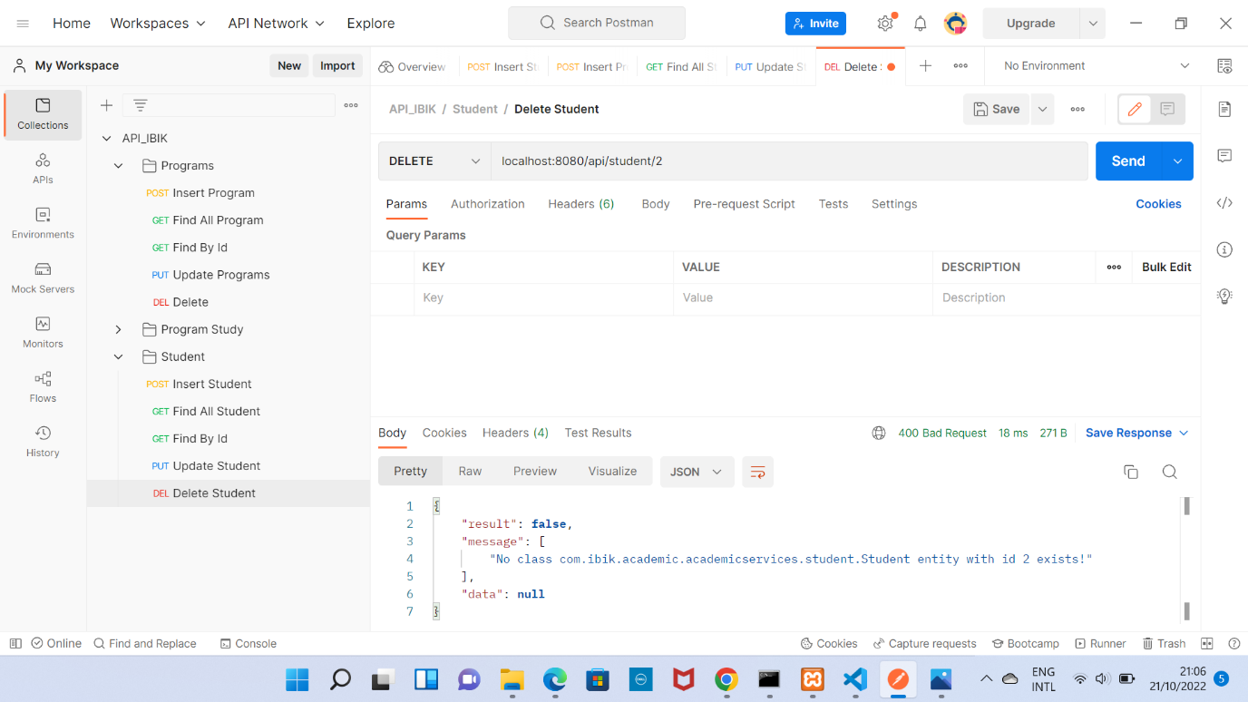

Gambar 26 Delete Error